Happy Easter

COVID-19 update:

- PPE guidance for homecare is due to be updated shortly. We will let you know of changes as soon as the guidance is published. Make sure you have sufficient supplies of PPE with you at all times.
- Please keep up with your weekly home testing for COVID-19. When you need more test kits please ask your manager for them.
- Let your manager know when you have had your 2nd vaccine, thank you.

Remember: Hands, face, space & fresh air

Compliments:

Adult social care team:

“I'd like to take this opportunity to thank everyone at SPDNS for the excellent care you all provided for my father. His carers were meticulous in ensuring he had everything he needed and was always comfortable. He looked forward to the visits and often told me how terrific everyone was. Thankyou also for the valuable help given to me - I really appreciated that someone very helpful was always on call whenever needed”

Hospice at Home:

“Thank you for all your outstanding care and support in enabling our dad to achieve his last wish, passing away peacefully in his bungalow, in his bedroom, in his bed. We will always remember you all with immense gratitude”

April is stress awareness month healthcare professionals and health promotion experts across the country will join forces to increase public awareness about the causes and cures for our modern stress epidemic.

Here are some tips during Stress Awareness Month

- Unplug for a while. Occasionally give yourself the time to unplug. ...
- Eat well. Good food and regular meals provide the energy you need to deal effectively with stress.
- Be active. We all know that staying active is good for us. ...
- Sleep well. ...
- Do Something Fun. ...
- Meditation and deep relaxation. ...
- Take your time. ...
- Ask for help.

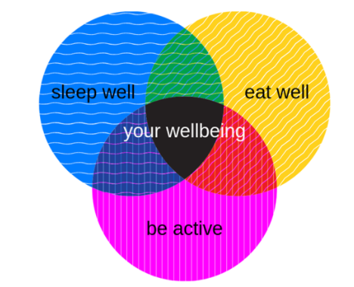

Thank you everyone for
your continued hard work

