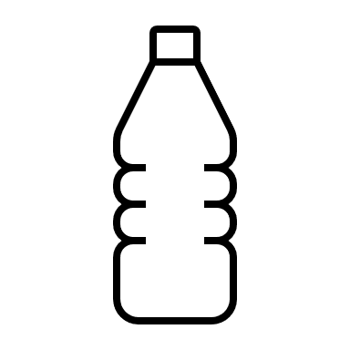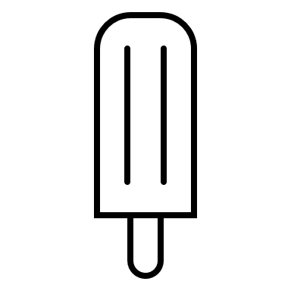

A really big thank you to everyone for working throughout this very hot weather. We know it has been very hard recently and we really appreciate all that you do.

Infection prevention and control guidelines
Following memos sent to you we have recently updated our infection prevention and control guidelines. Copies are now available on the staff intranet so please read through. Government guidance for adult social care organisations working in England have also been updated (7th July 2022).

Here are some key points:

- All care staff must continue to carry out twice weekly lateral flow device tests. PCR testing is no longer required.
- All care staff must continue to wear face masks for all visits
- We have updated our uniform code as explained in a memo to you on 14th July.
For reason of health and safety you should:
- be “bare below the elbows” when carrying out personal care. This means having short sleeves or sleeves securely rolled up above the elbow.
- to support safe hand hygiene you should have clean, short fingernails which are free from nail products including artificial nails.
- You should cover any cuts or abrasions with a waterproof dressing.
- One plain metal ring may be worn but must not be ridged or have a stone
- We have updated our standard infection control precautions, hand hygiene guidance, respiratory and cough hygiene and reviewed our PPE guidance.

Make sure you drink plenty of water to keep yourself hydrated in this hot weather
Everyone is at risk of dehydration in hot temperatures which is why it’s always important to keep hydrated, but during hot weather it’s even more important to drink plenty of fluids like water – especially for the elderly or if you have a health condition such as diabetes.

- Drinking water contains several electrolytes (including calcium, chloride, fluoride, magnesium, potassium and sodium) all of which play an important part in our bodily functions.
- The water we drink is absorbed by the intestines and then circulated around the body in the form of fluids, such as blood. When we drink this process can happen in as few as five minutes
- Water is vital for moving oxygen, nutrients and waste products into and out of the body’s cells. It is needed for all digestion and absorption functions
- Water helps to regulate body temperature and serves as a cushioning component between joints, in the spinal cord and in the brain
For those reluctant to drink water, why not try homemade ice lollies made with watered-down fruit juice or squash, or adding fruits such as lemons and limes to your bottled water?
Although you may not feel particularly hungry in the heat, don’t stop eating. Perhaps try to have smaller, more frequent light meals and incorporate lots of fruits and salad which are full of water and will help hydrate you.
Sun safety
We all know sunscreen is important but using the right one can be a little confusing. The NHS’s general advice is a sun protection factor (SPF) of at least 15 to protect against UVB and at least four-star UVA protection. Of course, the best protection from the sun is staying out of it at the hottest parts of the day, from 11am to 3pm. For more sun safety tips visit nhs.uk.

