**Staff news:** We welcome Mansur to the adult team and wish him well

**College Survey June 2023 -** A big thank you to the college team for all your hard work over the past year. We undertook a survey seeking feedback from college students and the professionals who work with them. It was a very positive survey with some lovely comments about our staff. Well done team, you are very highly valued!

**Confidentiality and Respect -** Please can we remind all staff about the confidentiality statement that we all signed when we first started with SPDNS. We have included an extract below:

*“I will hold in the strictest confidence all information of a personal nature that I learn about service users, their home (including all door entry / alarm systems), their families and carers, and other members of staff. I will share such information with others inside the organisation only if I am required to do so as part of my duties, and in ways that will safeguard its sensitive nature”*

**Recommend at friend! -** A reminder to everyone that you can claim an introductory bonus of £150 if you successfully introduce someone to join SPDNS, terms and conditions apply. We often find that this way of recruiting is very successful. So please let us know if you know anyone who might be interested in working for SPDNS – thank you!

**Training news:**



17th July: Dementia, Learning disabilities and mental health

18th July: Safeguarding

19th July: College Update

20th July: First Aid

21st July: Medication

25th July: Update Training

All training dates for the rest of the year are now on the staff intranet so please take a look. To book onto training please contact Pat who can book you onto the training days. Her email address is: [patbrand@spdnshomecare.com](mailto:patbrand@spdnshomecare.com). Moving forward we are reverting back to face-to-face update training which will take place at the SPDNS office in Westcliff. A reminder that you need to attend update training once a year and it is your own responsibility to ensure that you keep yourselves up to date with all training.

For any online training the registration guide can be accessed through contacting me directly on my email: amytearle@spdnshomecare.com where I will support where required.

**Health news:** ‘Health is a state of mind. Wellness is a state of being’

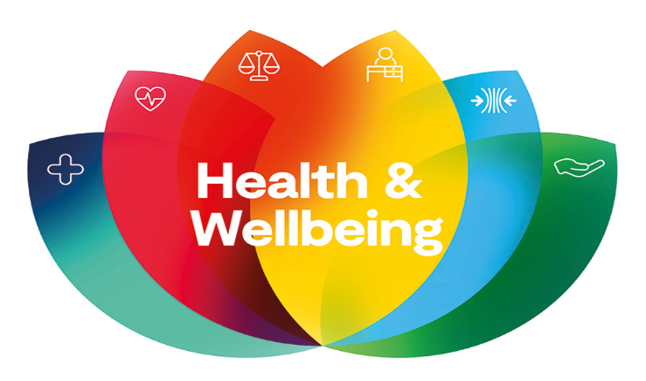

**The wellbeing 9!**

1. Be resilient
2. Be kind to yourself & others
3. Practice self-care
4. Connect and talk
5. Take notice who, and what’s around you
6. Be active and socialize
7. Know where to find help and ask for it
8. Understand that looking your own mental health is as important as your physical health
9. Take care of yourself and others



**July is Sarcoma awareness month.** The prognosis for the UK’s sarcoma patients has changed little over the past 40 years, late diagnosis is a key factor. Sarcoma UK want to get people diagnosed earlier and have better treatment options for life with and beyond bone and soft tissue cancers.

**For more information:** <https://sarcoma.org.uk/sarcoma-awareness-month/>